

Documentation Center

Genesis 8 Cross-Figure Resource Kit
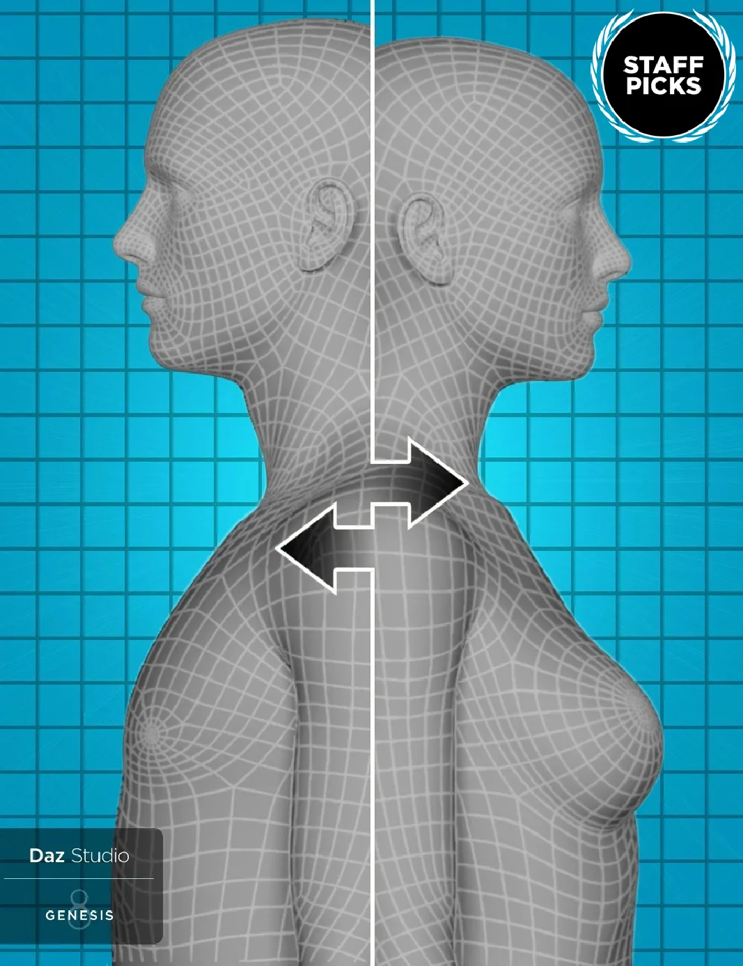
Genesis 8 Cross-Figure Resource Kit
[https://www.daz3d.com/genesis-8-cross-figure-resource-kit]
Product Name:

Product ID: | 59859
Published Artist(s): | Daz Originals [https://www.daz3d.com/daz-originals/]
Created By: | N/A
Release Date: | 2019-07-25

Product Information

Required Products: None

The Genesis 8 Cross-Figure Resource Kit provides the tools and information that enable developers to create conforming content that allows being 'Fit to' more than a single supporting figure possible in Daz Studio. For example, a single item that is intended for use on Genesis 8 Female(s) that can also (optionally) be used on Genesis 8 Male(s).
Would you like your clothing to fit both Genesis 8 Female and Genesis 8 Male? Do you want to add fits for a different Genesis 8 generation shape? With the Genesis 8 Cross-Figure Resource Kit, you can.
This is different than the included “Auto-Fit” feature. The Genesis 8 Cross-Figure Resource Kit allows you to project the shapes and skeletal changes of one figure to “conformers”, such as clothing, Geo-Grafts and hair – and then save those assets out, allowing your item to fit the “wrong” shaped figures.
For content creators, this helps customers use your product across both male and female figures. As a customer, you can take a product you already own and do the same.

Product Notes

Installation Packages

Below is a list of the installation package types provided by this product. The name of each package contains a Package Qualifier, which is used as a key to indicate something about the contents of that package.
1 Core 1)

Not all installation packages provide files that are displayed to the user within the interface of an application. The packages listed below, do. The application(s), and the location(s) within each application, are shown below.

Genesis 8 Cross-Figure Resource Kit (Core)

You can find new icons for loading this product in the following DAZ Studio Folders: “Scripts:Utilities”
You can find new icons for this product in the following DAZ Studio Categories: “Scripts:Utilities”

Additional Details

Process Overview

This document will take you step by step through adding the shape/morph parameters and saving your assets for personal use, or distribution with your shippable products.
What are the Requirements? How do I Install the Kit?
The Step by Step Process Loading the Base Figure Loading the Conformer
Applying the Parameter Run the Script
Save the Asset Final Results
Things to Keep in Mind Troubleshooting

Foundation

In order to use this resource kit, you need to have Daz Studio 4.6.1.33 or higher installed on your system. You should have a good working knowledge of Daz Studio and be comfortable with the Parameter pane ettings, as well as saving out new assets.

Process

The following steps will walk you through the full process. At the end, we have included a few notes and troubleshooting tips. Let's begin!

Step 1 – Load Figure
The first thing you need to do is open Daz Studio and start with a new blank scene. In our example, we will create an asset created for the Genesis 8 Female, to be used on the Genesis 8 Male figure. Start by loading the correct figure. In our example, we want to fit from Genesis 8 Female to Genesis 8 Male. Go ahead and load the Genesis 8 Female figure into the scene.
Once she is loaded and selected, you will see a new entry in Parameters called “Cross-Figure” as shown in the image below:
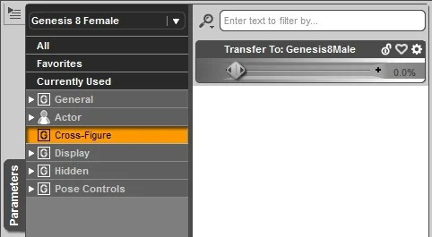

Step 2 – Load the asset Conformer

Next we want to load and “fit” our clothing item to the figure.
Load your item
Make sure it is “Fit To” your figure.

Step 3 – Apply the Parameter
Select Genesis 8 Female in your scene and do the following: Select “Cross-Figure” in Parameters.
Find the “Transfer To:” parameter dial for the desired target figure. (In this case, Genesis 8 Male) and Dial it to “100%”.
At this point, you will see the Genesis 8 Female change to the Genesis 8 Male shape. We are ready for the next step.

Step 4 - Running the Script
Select the “Conformer,” (the item you are conforming to Genesis 8 Male), from the Scene Tab, and do the following:
Execute the “Cross-Figure Setup” script found in the Content Library pane under “Scripts > Utilities”.
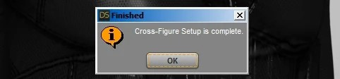
When the script has run successfully, you will see a pop-up stating: “Cross-Figure Setup Complete.” Select “OK”.
Your Top now has three (3) new parameters under: “Parameters > Hidden > Cross-Figure”. You may need to check “Show Hidden Properties” in the Parameter Menu to see all three:
XID_Genesis8Male FID_Genesis8Male
XID_Genesis8Female

NOTE: If you run the script a second time, you will get the following error: “The follow for this figure has already been made. Delete the property “FID_Genesis8Male” and re-run to recreate setup.” Select “OK” and see the Troubleshooting section below.

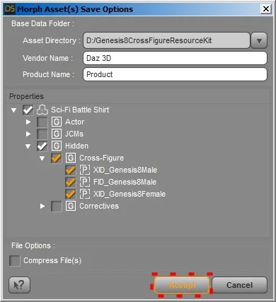
Step 5 - Saving the Asset
It is time to save your new asset.
Make sure you have the “Top” selected in the Scene Tab.

Click “File > Save As > Support Asset > Morph Asset(s)”.
Check the “Asset Directory:” path and make sure it is pointing to your installed content location.
Give it a Vendor Name. Give it a Product Name.
Expand “Top > Hidden > Cross-Figure” and select your three new parameters.
Click “Accept”
Your Morph assets are now added to the data folder for the “Conformer”. The next time it is loaded, you can “Fit To” the Genesis 8 Male figure.

Notes to Consider

Here are some things things to consider:

Content Developers and Creators can supply an alternative custom shape/morph to that of the Daz Studio projected version, by using a “vert compatible” OBJ of their own making.
Because weight mapping varies from figure to figure, this may not work as expected with all content. You may get resulting poke through on the alternate figure, particularly in the hips, torso and shoulder areas.
Unlike with Genesis 2, this process does not work well on Geo-Grafted items because Genesis 8 Male and Female have different geometry so it is unable to Geo-Graft.
There are times when using Auto-Fit will give better results. Utilize the tools that give you the best fit for the items you are working with.

Troubleshooting

Re-running the script before saving the asset

There may be a time, rarely, when you need to re-run the script. If you do, you will get the following error: “The follow for this figure has already been made. Delete the property “FID_Genesis8Male” and re-run to recreate setup.”
If this happens, and you do in fact want to re-run the script you have two (2) options:

First, start over with a new scene. Since there are very few steps involved, this is a viable option.
Second, you will need to follow these steps:
Select the item in the Scene Tab.
On the Parameters pane menu, make sure to “Show Hidden Properties”.

In Parameters highlight “Hidden > Cross-Figure”.
R-Click any of the three properties listed and select “Edit Mode”.
R-Click each of the three and choose “Delete Selected Property”. Re-run your script.

Re-running the script after saving the asset

If you need to re-run the script after you have saved the asset, you will need to browse to the 'data' folder and manually delete the three Cross-Figure files associated with that figure fit.
In other words, if you have more than one folder inside the data folder's Cross-Figure folder, only delete those associated with the fit you want to remove. If you delete the whole folder, you will lose any other fits you may have created, or acquired with the product.

Wrap-Up

This document is intended to help you through the basics of creating a Cross-Figure asset for Genesis 8 figures, thus allowing you or your customers to have a broader use of your products. By running a simple script, you can project your morphs and then save an asset to include these Cross-Figure abilities.
Have fun, experiment and enjoy the Genesis 8 Cross-Figure Kit! File List

Resolved Issues

None

Known Issues

None

Support
Visit our site for technical support [http://www.daz3d.com/shop/help/help-contact-us] questions or concerns.

1)
The contents of this package are in DAZ Studio Native formats

